**Evidence for Implementation and Testing Unit.**

Hamish Stewart

E16

January 2018

**I.T 1- Demonstrate one example of encapsulation that you have written in a program.**

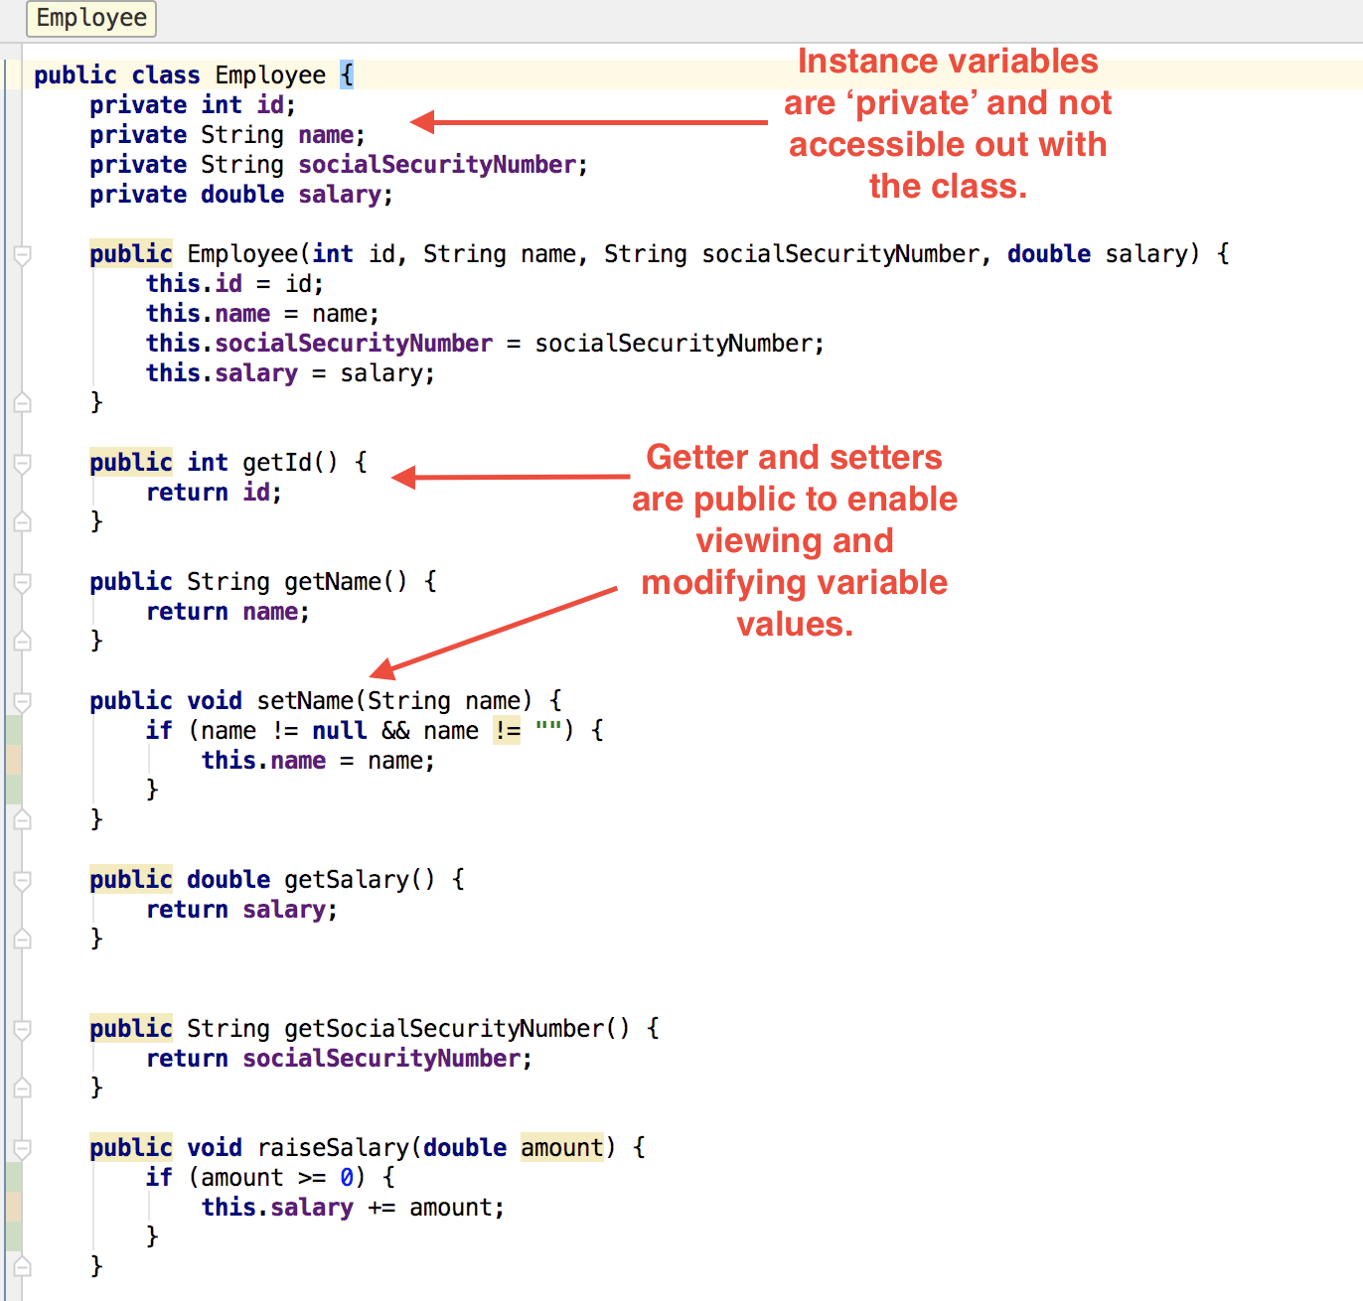

**I.T 2 - Example the use of inheritance in a program.**

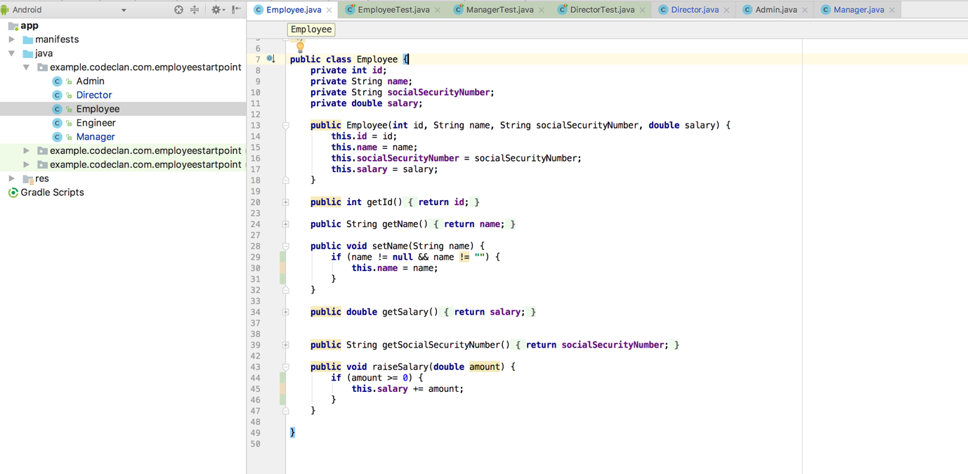

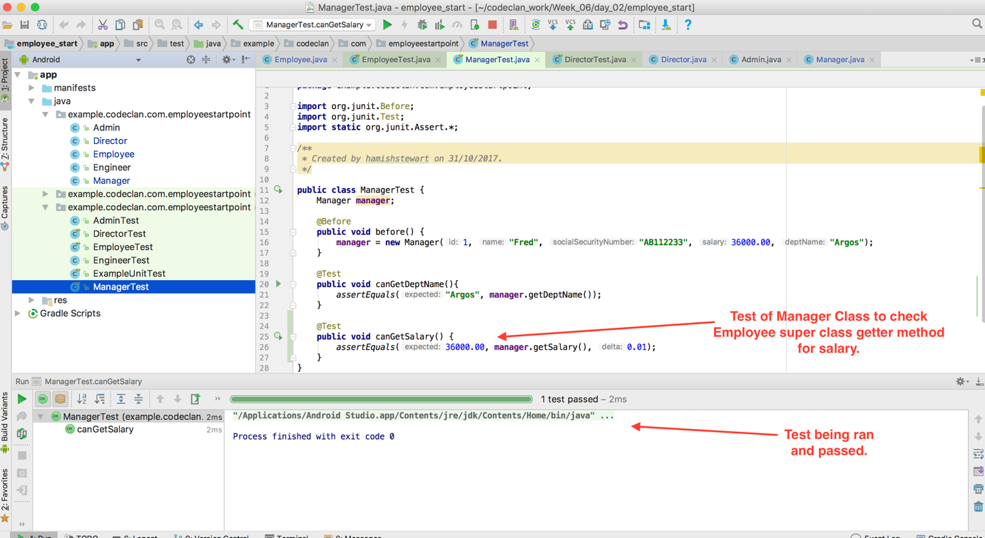

**I.T 3 - Example of searching**

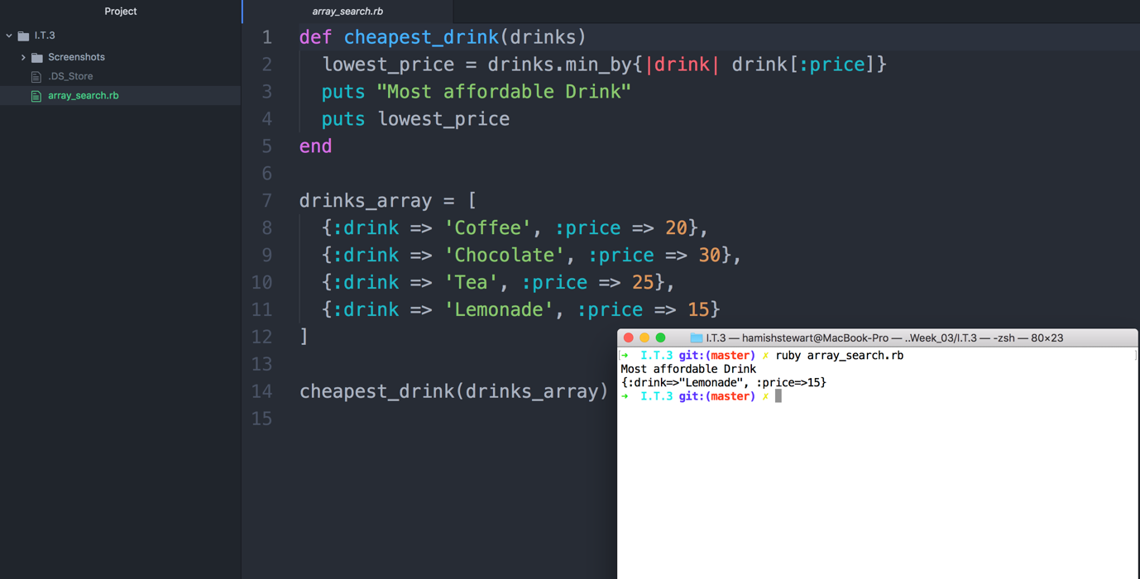

**Search for the lowest priced drink in the array.**

**I.T 4 – Example of sorting**

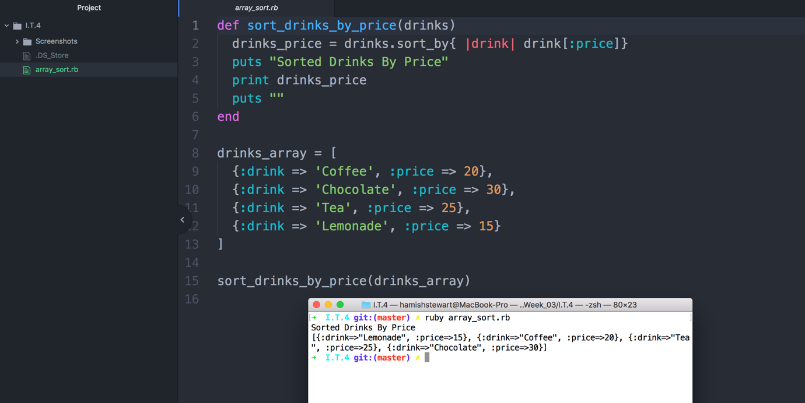

**Sorted drinks by price.**

**I.T 5 - Example of an array, a function that uses an array and the result**

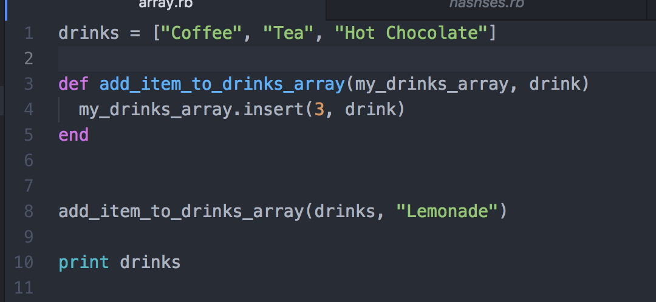

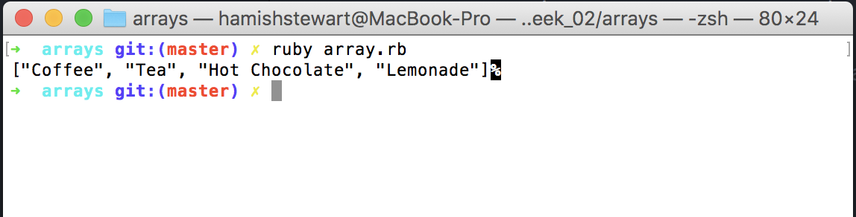

**Added Lemonade to original array.**

**I.T 6 - Example of a hash, a function that uses a hash and the result**

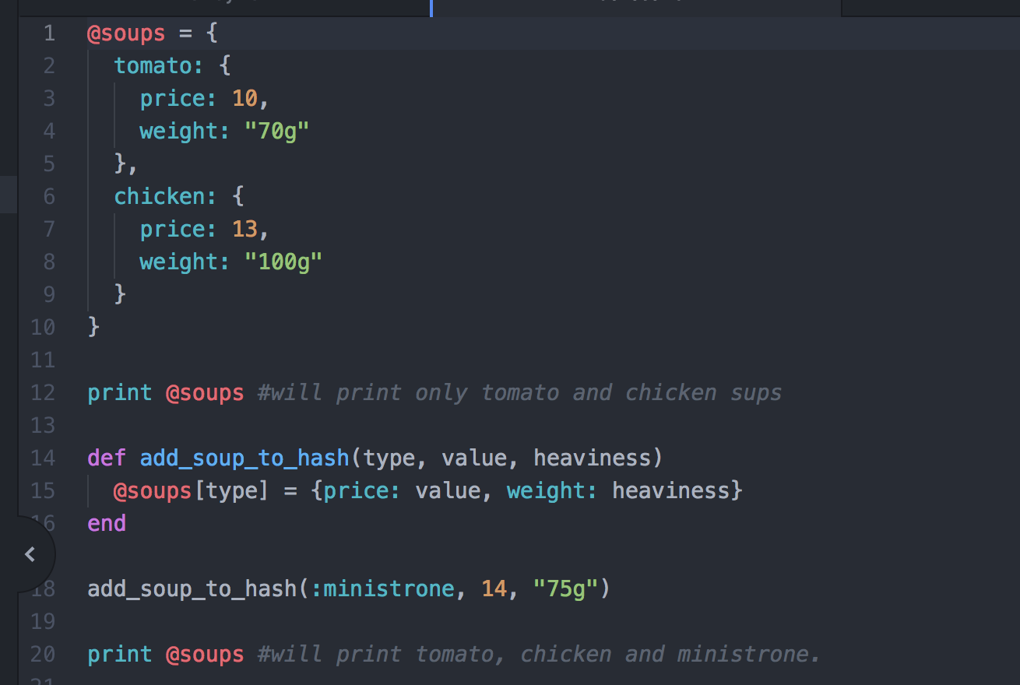

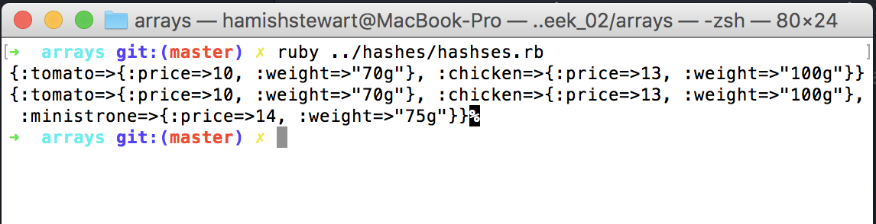

**Hash with Chicken and Tomato soup and a function to add minestrone soup.**

**I.T 7 - Example of polymorphism in a program**

